Justin Lawrence

WSU Fall 23

CPTS 422

Test Case report

For my test cases I had about 6-9 test cases per check. They were pretty straight forward for the most part, but I did run into issues when it came to achieving full branch coverage. Once I created my first set of tests, I was able to copy them and adjust them to fit other checks. I used Mockito’s spy function so I could preserve the behavior of the class methods being tested. I created a mock of AST to represent the AST object which is how I tested the nodes in the AST tree. From there I used verify to check the interactions between the methods and mockAST.

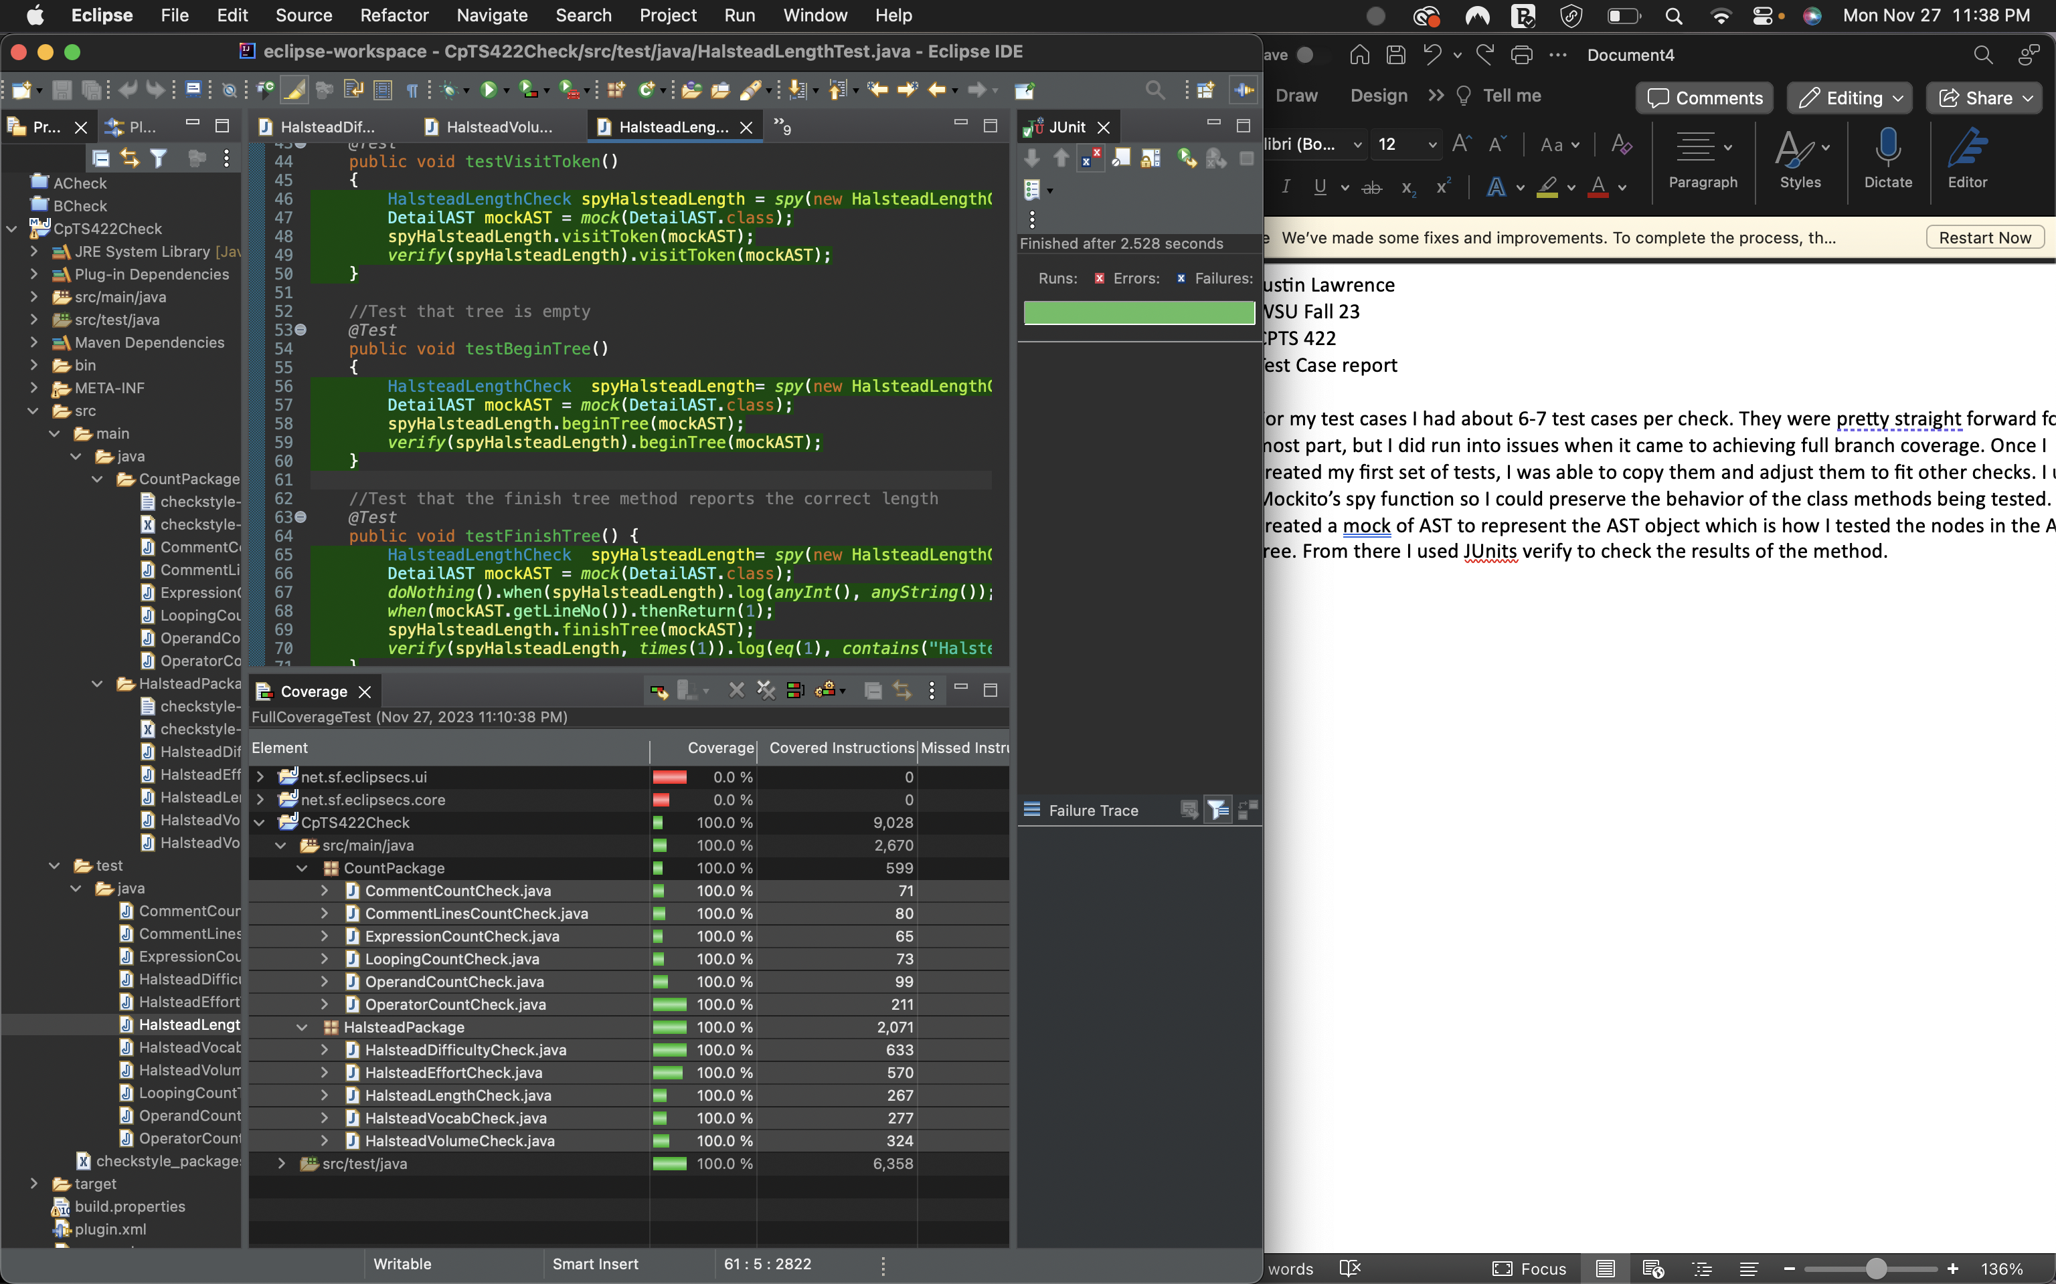

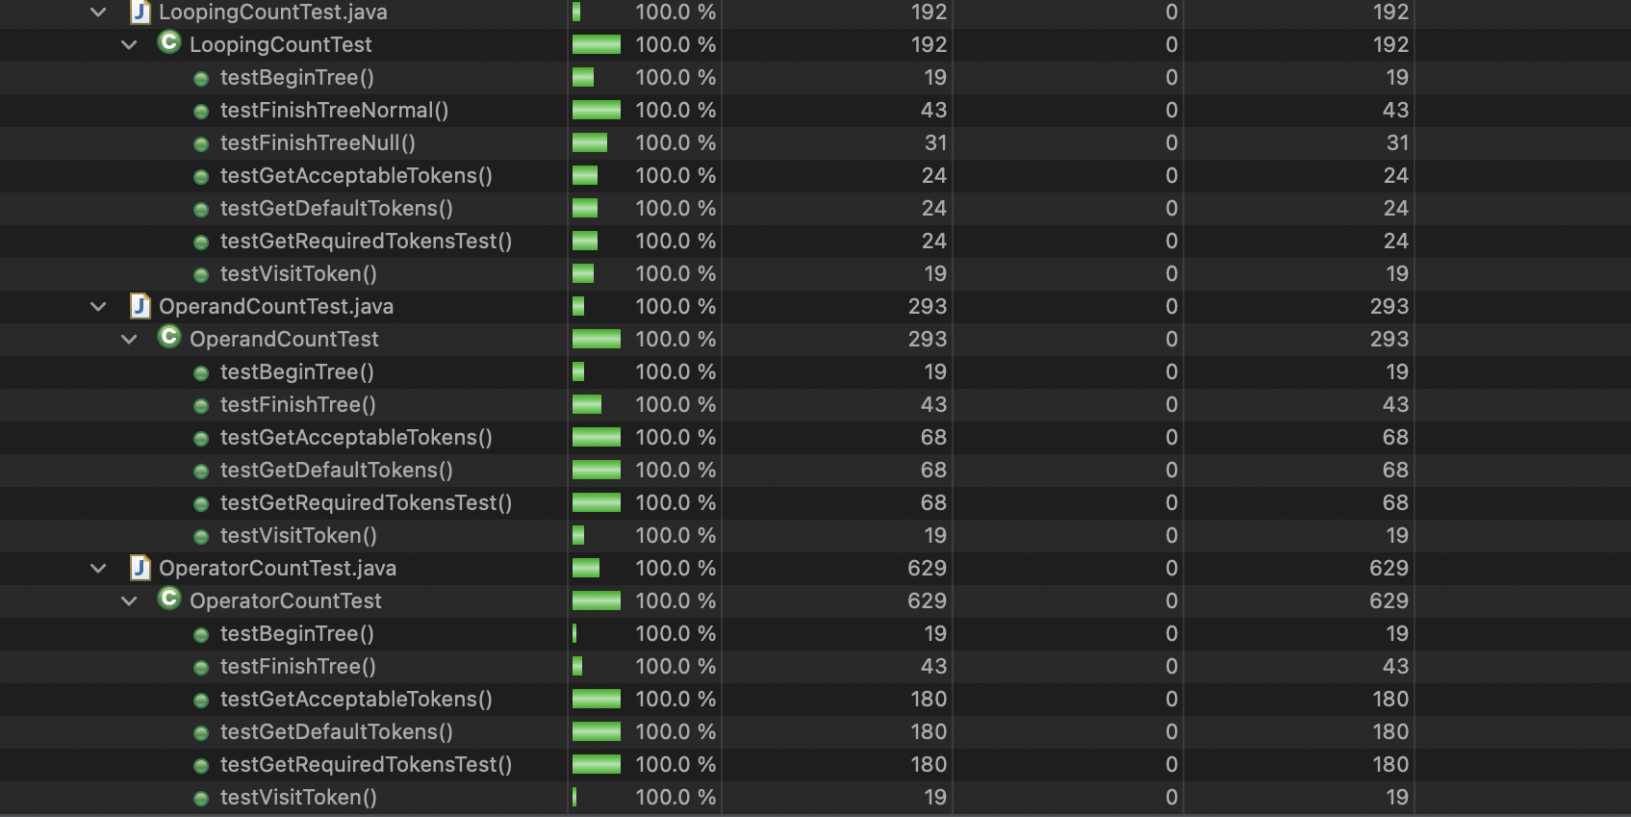

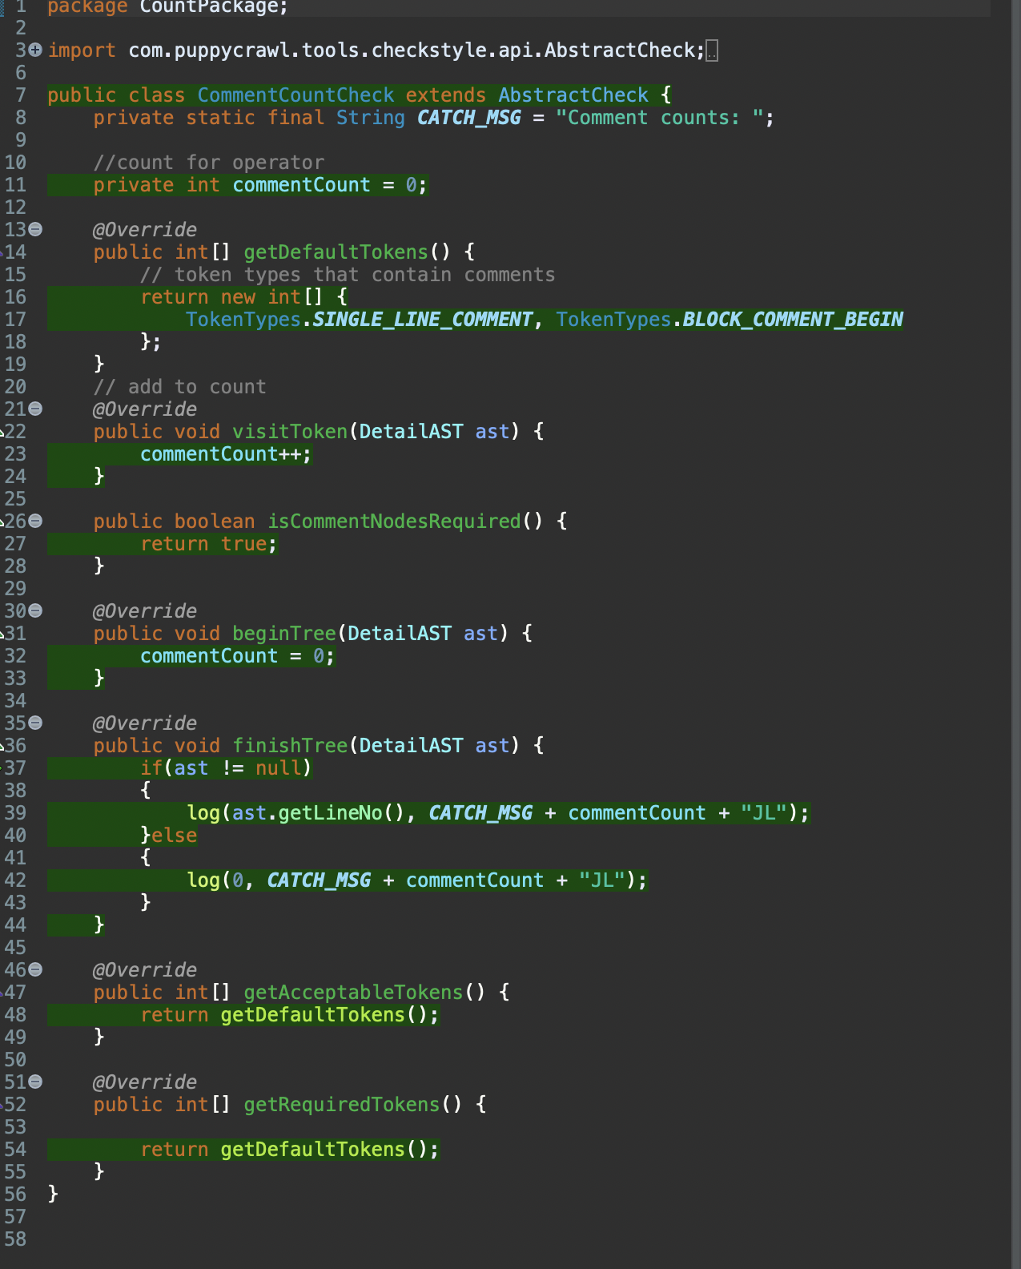

To achieve branch coverage for finishTree(DetailAST ast)

I created two test cases for finishtree one that had ast as null and one that did not, this way I was able to achieve branch coverage by testing for true and false. This is the example for the first two checks but I used the same approach for visitToken and finishTree() in the other tests as well.

